Starr Academy Teacher Connie Kimball Recognized through Herb Kohl Fellowship Award
Starr Academy Teacher Connie Kimball Recognized through Herb Kohl Fellowship Award
NEW LONDON, WIS., — April 17, 2018 — Rawhide, Inc., a leading residential care provider, is pleased to announce that Connie Kimball, teacher at Rawhide’s Starr Academy has been recognized as a recipient of the 2018 Herb Kohl Fellowship award. This is the first time in Rawhide’s history that a teacher at Starr Academy has been honored with the award.
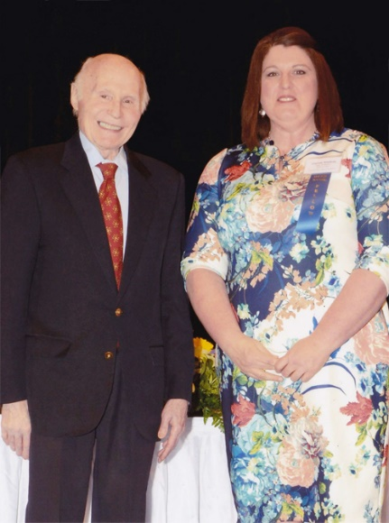
The Kohl Teacher Fellowship program recognizes and supports teaching excellence and innovation in the State of Wisconsin. Its goal is to support teachers in the pursuit of their unrealized goals for their classrooms or professional development. The 100 Herb Kohl Fellowship recipients and the 100 schools of those teachers will each receive a $6,000 grant and will be recognized at a spring banquet, which has been rescheduled for April 28.
“Connie Kimball has been an outstanding educator at Starr Academy for almost 15 years. What sets Connie apart is her love and commitment to her students and her passion for learning,” stated Dan Birr, Director of Education at Starr Academy. “Over the last decade, every student that has graduated with a Starr Academy diploma owes Connie a huge debt of gratitude for the work that she has done with them. One of her greatest achievements is the hope that she has brought to boys who were on the brink of losing that hope.”
Starr Academy is fully accredited by the Wisconsin Religious and Independent Schools Accreditation (WRISA). Many students make dramatic improvements in academics while at Rawhide. The entire teaching staff works hard to help each student catch up on their credits before being discharged from the program.
About Rawhide: Rawhide offers residential care and outpatient services dedicated to helping at-risk youth and their families lead healthy, responsible lives. Located outside of New London, Wisconsin, Rawhide Boys Ranch emphasizes a faith-based residential environment as an alternative to juvenile corrections for court-referred boys. In addition, Rawhide provides services to youth and their families through community-based programs such as foster care, outpatient counseling, equine therapy, adventure based summer camps and Parent Weekends. Learn more about Rawhide by visiting its website at www.rawhide.org
###
Contact: Scott Sawinski
Public Relations Manager
Rawhide Boys Ranch
(920) 397-0801
ssawinski@rawhide.org

