Rawhide Receives Donation from Green Bay Youth Making a Difference
Rawhide Receives Donation from Green Bay Youth Making a Difference
NEW LONDON, WIS., — March 13, 2018 — Rawhide, Inc., a leading residential care and outpatient counseling services provider, received a generous donation of nearly $8,500 from three area youth as part of their community service project. Snap Out Of It, created by Holy Family School (Green Bay, Wis.) students Joey Bonadonna, Andrew Delvoye and Max Baek, was a viral campaign that took place February 9-11, 2018 encouraging individuals to put down their phones and electronic devices.
Snap Out Of It was a community challenge to limit screen time for at least 24 hours and spend quality time with family and friends. They suggested participants have a game night, make a meal together, go sledding, but whatever it was, do it together with no distractions. They made a community appeal to make a pledge for every hour they were electronics-free to support Rawhide.
“Rawhide is honored to be the recipient of the funds raised from the Snap Out Of It pledge,” stated Alan Loux, Rawhide President and Chief Executive Officer. “It’s a great example of today’s youth bringing awareness to a problem that is affecting many, while at the same time supporting at-risk youth that Rawhide serves.”
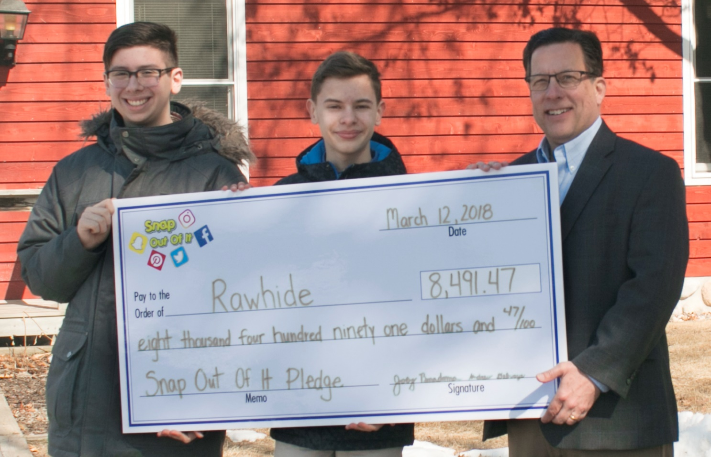
Joey (left) and Andrew (middle) present a check to Alan Loux, Rawhide President and Chief Executive Officer from the Snap Out Of It pledge.
About Rawhide: Rawhide offers residential care and outpatient services dedicated to helping at-risk youth and their families lead healthy, responsible lives. Located outside of New London, Wisconsin, Rawhide Boys Ranch emphasizes a faith-based residential environment as an alternative to juvenile corrections for court-referred boys. In addition, Rawhide provides services to youth and their families through community-based programs such as foster care, outpatient counseling, equine therapy, adventure based summer camps and Parent Weekends. Learn more about Rawhide by visiting its website at www.rawhide.org
###
Contact: Scott Sawinski
Public Relations Manager
Rawhide Boys Ranch
(920) 397-0801
ssawinski@rawhide.org

