Rawhide Receives Donation for Milwaukee Community Counseling Program

Rawhide Receives Donation from West Bend Mutual
to Support Community Counseling Program
Rawhide Boys Ranch, a residential and counseling alternative for at-risk youth received a $10,000 donation from West Bend Mutual Insurance Company to support its Youth and Family Counseling Clinic in Milwaukee. Jerry Aman, West Bend resident and agent with R & R Insurance submitted Rawhide for consideration of the grant from West Bend.
Rawhide which has clinics in Green Bay, Appleton, and New London opened its fourth Outpatient Clinic in Milwaukee and West Bend last November. Mike Rintelman is the lead therapist and has nearly nineteen years of experience working in youth and family therapeutic counseling.
Located outside of New London, Wisconsin, Rawhide Boys Ranch emphasizes a faith-based residential environment as an alternative to juvenile corrections for court-referred and at-risk young men. In addition, Rawhide provides services to youth and their families through community-based programs, such as outpatient counseling. Families interested in scheduling an appointment for outpatient counseling services should visit www.rawhide.enfusendev.com/strongfamily or call (920) 965-7718 or toll free 1-877-300-9101. Most major health insurance plans are accepted and a sliding fee is also available. Rawhide is largely supported by donations of cars, boats, campers, and financial gifts. Learn more about Rawhide by calling (920) 982-6100 or visiting the website at www.rawhide.enfusendev.com.
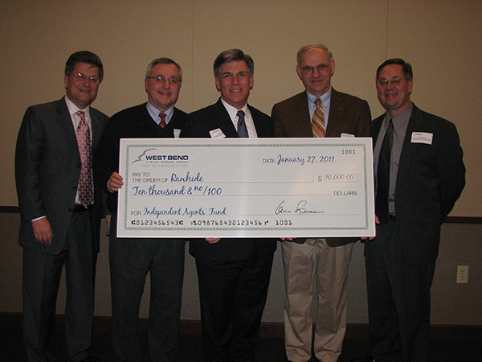
West Bend Mutual presented a check for $10,000 to Rawhide Boys Ranch for support of the Milwaukee Outpatient Counseling Clinic. Pictured (left to right) are Dale Kent-West Bend, Phil Hway-Friends of Rawhide Volunteer Chair, John Solberg-Rawhide Executive Director, Jerry Aman-Friends of Rawhide Volunteer, and Dave Borash-Rawhide Development Manager.

